The M-Editor in Eclipse and Rational ClearCase
The M-Editor for Eclipse is a combination of Eclipse plug-ins that provide the capability to load an M routine from a VistA server, view and edit the routine, and then save the modified routine to the VistA server (and possibly other specified servers as well). The M-Editor for Eclipse can be use with the Rational ClearCase plug-in for Eclipse to provide Version Control for the M routines as well. This document describes the setup and use of an Eclipse version for editing and version control of M routines.

What do you need?
- The server side patches (XT*7.3*81, XT*7.3*101, and XT*7.3*107) will need to be installed on any VistA servers to be used for development. These are in the process of being released. However, at the current time contact joel.ivey@va.gov to obtain these patches (if you need the Host File version instead of the KIDS build, please specify that).
- The Eclipse Integrated Development Environment (IDE) with the M-Editor and related plug-ins, and if you are going to do version control, e.g., ClearCase, the appropriate plug-in(s) for the version control system. The location of a full Eclipse build with the M-Editor and ClearCase plug-ins is given below.

Installing Eclipse with the M-Editor and ClearCase plug-ins.
- Go to http://vaww.vista.med.va.gov/iss/developers.asp#developer_tools and download the version of eclipse with the M-Editor and ClearCase (currently, this file is Eclipse_3_2_2_with_M-Editor_and_ClearCase_110919.zip). Eclipse version 3.2.2 is an older version and is used because it gives the best functionality in the ClearCase perspective with the available ClearCase plug-in and the version of ClearCase that is currently being used by the VA.
- Unzip the file into C:\ with the 'All files/folders in Archive' selected and 'Use folder names' checked (it will create the directory C:\Eclipse and place the other files under it). You can use other folders as well, but do not put it into a folder containing spaces in its name (e.g., Program Files).
- Run the file Eclipse.exe in the C:\Eclipse directory.
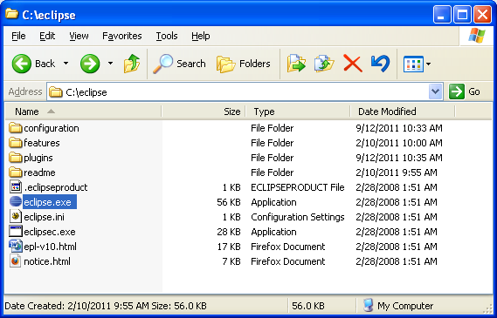
- As it starts up, it will prompt for a workspace location. The default is under Documents and Settings and the user's id. This can be used or another location can be specified, if desired.
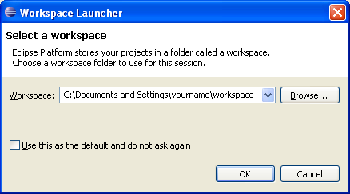
- The first time that Eclipse starts (or a new workspace is selected), it will open with a welcome screen – select the arrow on the right side. If desired this can be opened again from the help menu. 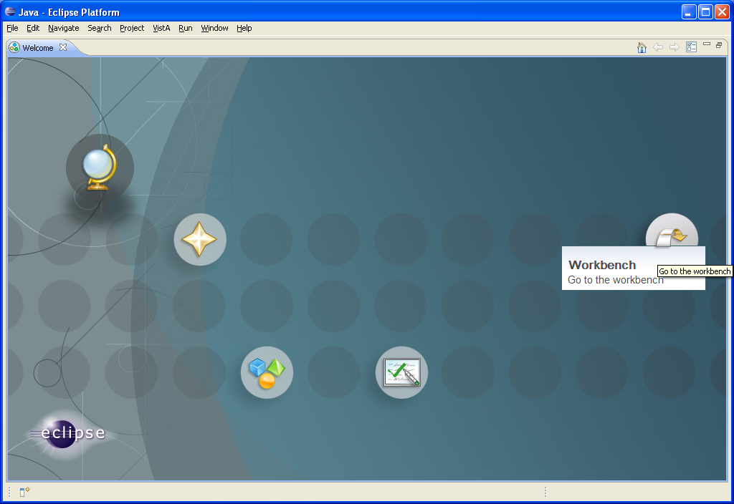
- The eclipse Integrated Development Environment (IDE) for Java (and M) editing is displayed. 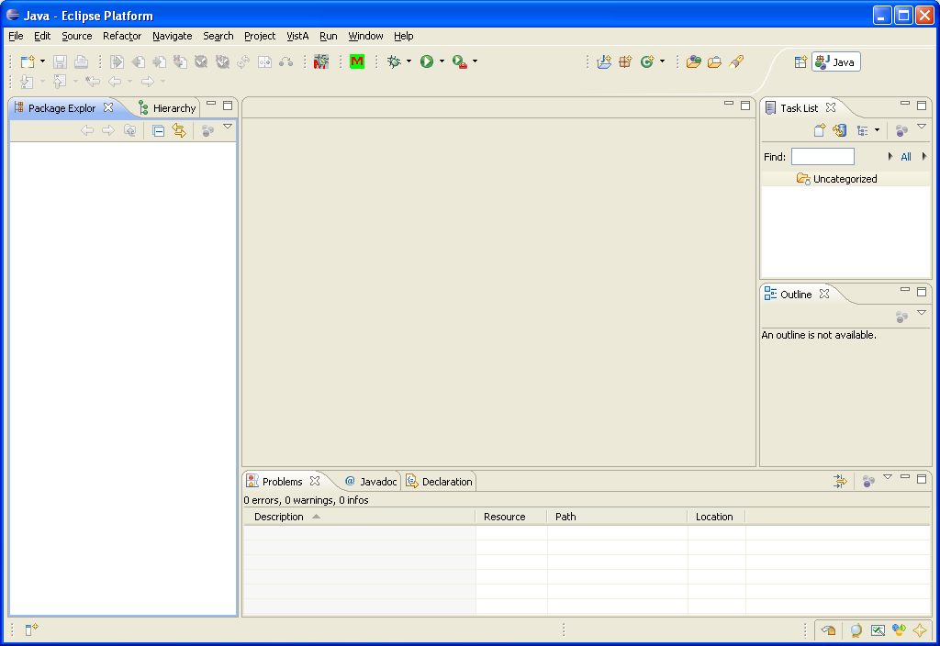
Setting up ClearCase for use with the M-Editor in Eclipse
- In the upper right-hand corner of the IDE select the small icon with a '+'-sign in the upper right corner, this will open a list of the different perspectives that are available. If ClearCase is not obvious, then open the Other… option for a full list of perspectives. Select ClearCase. 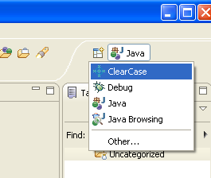 and open the ClearCase perspective. 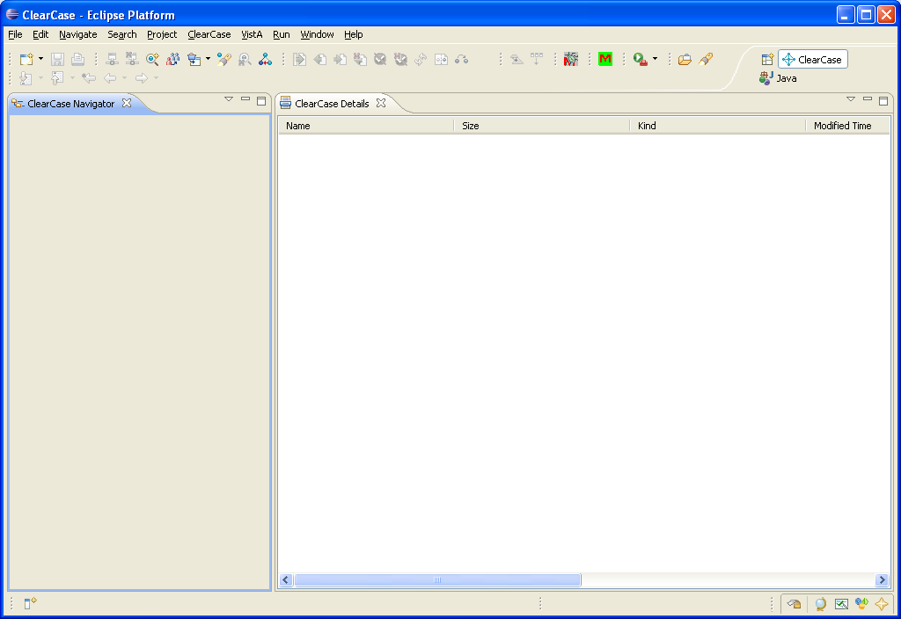
- From the menu bar select the ClearCase menu and then select 'Join a UCM Project'. 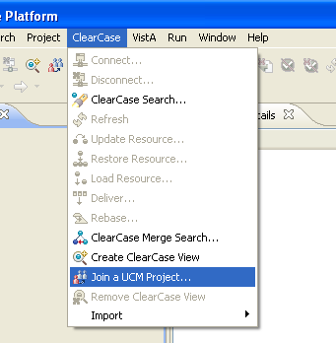
- Enter the address for your ClearCase web server, your username and password. 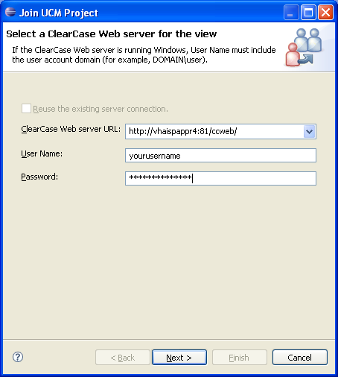
- From the options available select the desired project and click Next. 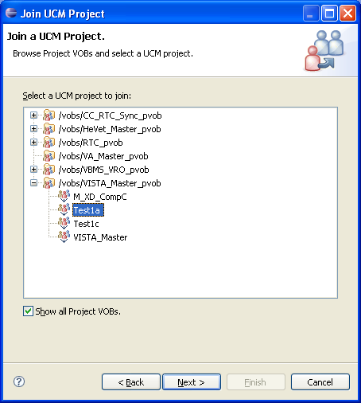
- Uncheck 'Create a new development stream' and click on the Reuse Stream button. 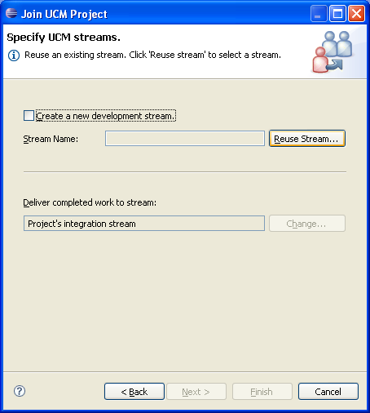
- Select the desired stream from those available. 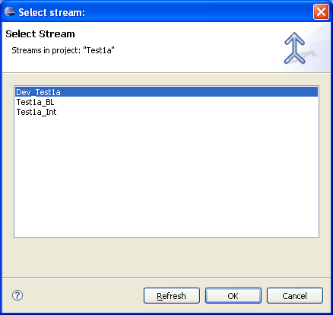
and click Next 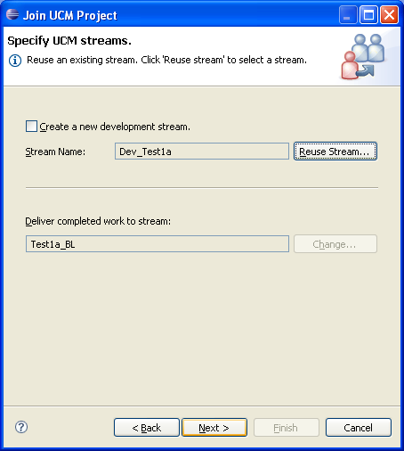
- Specify a location on your system that will hold your copy of the project click Next. 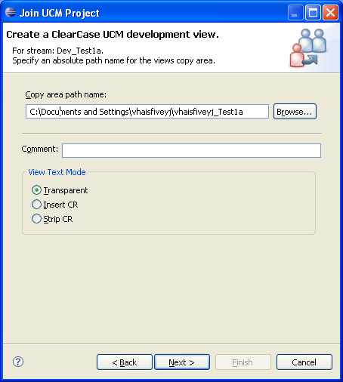
- Uncheck the 'Create a ClearCase UCM Integration view' box and click the Finish button. 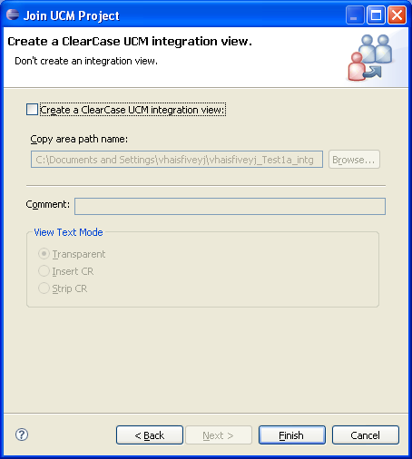
- 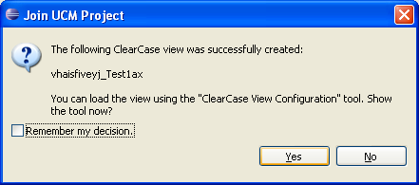
- 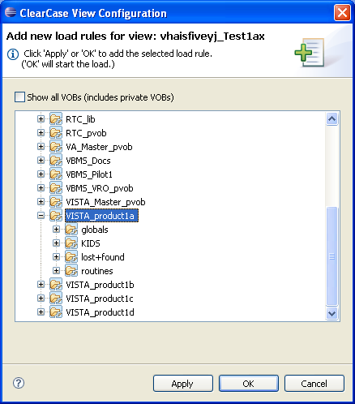
- 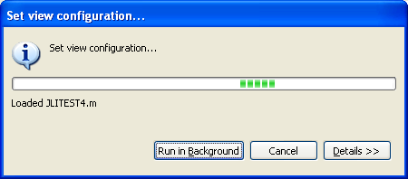
- This process will load a copy of the routines from the ClearCase server into the specified directory. [If you need to initially load routines from an account which contains the baseline routines (e.g., copies of already released routines), you might use the XTMRPRNT routine which is included in XT*7.3*81, to load all routines from the VistA account you would use
VISTA>D ^XTMRPRNT

All Routines? No => No

Routine: XUS*
Routine:
61 routines

ENTER RETURN TO START:
At this point turn on capture to a file [if you do not currently have the capture functionality in Attachmate Reflection, see http://support.attachmate.com/techdocs/2341.html] in a desired directory on the workstation (e.g., C:\test\XUSstar.txt), then enter the return to the prompt on the screen. It will list all of the routines at the end of the listing, turn off the routine capture. We have included a routine in the Eclipse directory to break out the individual routines from the file using a .m extension for them. Use a Windows command prompt and change to the directory into which the file was saved then enter the path to Eclipse, the program name BreakMRousFromXTMRPRNT.exe and the name of the file that was used.
C:>\Eclipse\BreakMRousFromXTMRPRNT.exe XUSstar.txt
The directory will now contain a copy of each of the individual routines with the .m extension and may be loaded into ClearCase as the original baseline.]

To return to the Java or M perspective, click the Java button in the upper right corner (or if it is not present open the list of perspectives and select Java.
Creating the project for editing M in Eclipse [If you are not using ClearCase, the default project will be created with the name 'mcode' (which could be modified in the Preferences)].
- From the menu bar select File – New – Project. 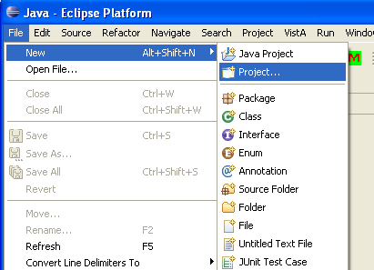
- In the Project dialog select General – Project 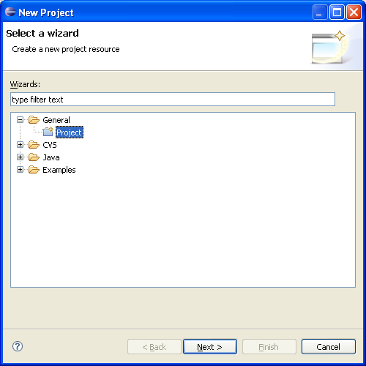
- Specify a project name uncheck the 'Use default location' box and either enter the directory or click on 'Browse…' and select the location where the routines are located.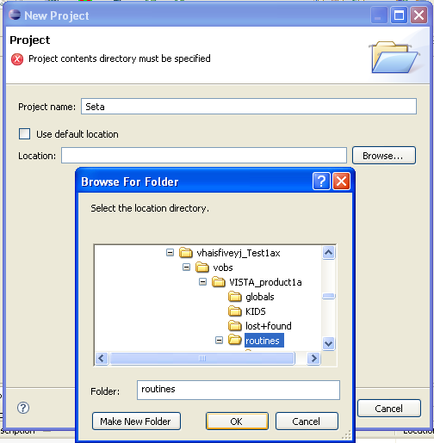 and click on Finish 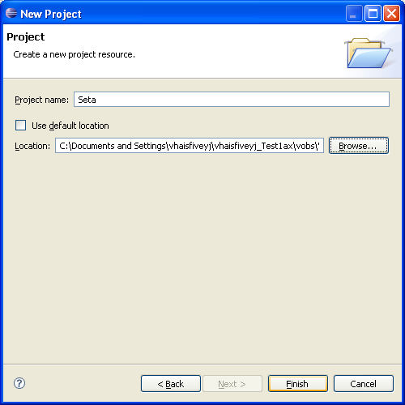
- Since Eclipse adds a .project file to the directory that ClearCase is controlling, you will be prompted whether to add it to Source Control, uncheck it and click Cancel. 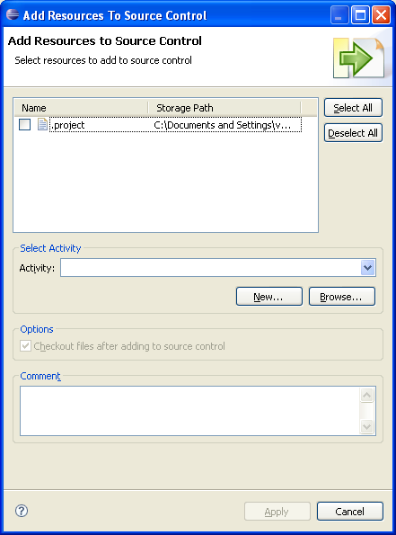
Setting up Servers (this is necessary whether ClearCase is being used or not)
- Prior to any editing, at least one server needs to be identified. From the menu bar select Windows – Preferences… 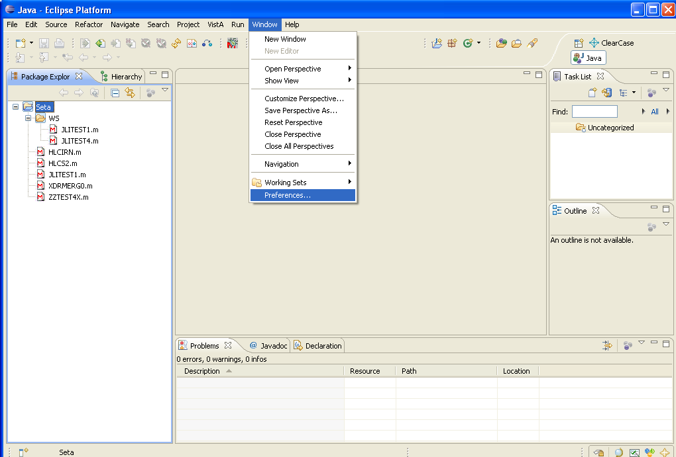
- Open the Vista and Connection entries from the tree. The working servers display will list only Primary;;;. Click the Add button 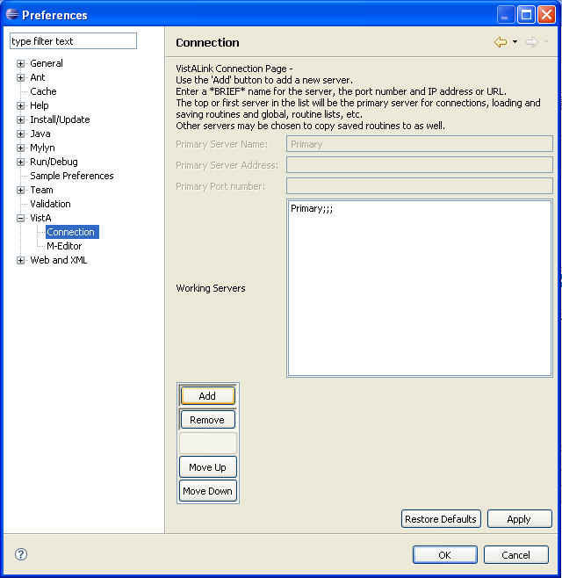
- In the dialog box for adding a new server, enter a brief identifier or name for the server, the address (which may be an IP address or a URL), and the VistALink port number to be used for the server. Note that a VistALink port number is required and NOT an RPCBroker port number. Only if you are using ClearCase (or another version control system), enter the name that was specified for your project. Then click OK. 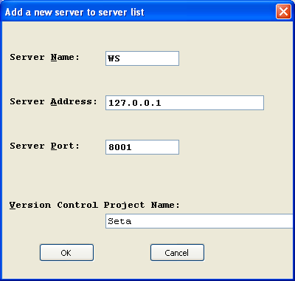
- You can select the new entry and click the 'Move Up' button to move the newly added server to the top of the list. If there are multiple servers listed, the top server is the primary server and it will be used as the server from which routines are loaded from and saved to as well as the server used for global listings, etc. Other servers may be selected when a modified routine is saved as additional locations to save the routine to. Move up and Move Down may be used to control the ordering of servers, but only the top position is significant. 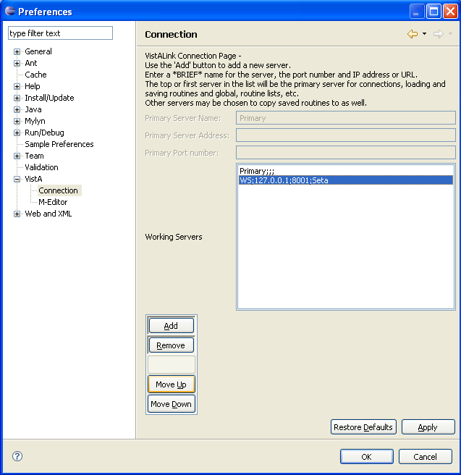
- To remove a server from the list, such as 'Primary;;;', select the entry and click on the Remove button. 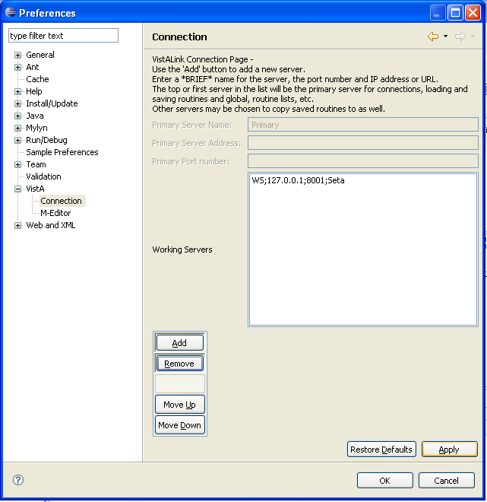
- The M-Editor prefences page under VistA can be used to turn on line wrap, control syntax coloring, etc. It is recommended that the Set default to update Routine File on Routine Save' and 'Save Routines by Server' (the latter indicating that servers will get their own directory for routines loaded, etc.). 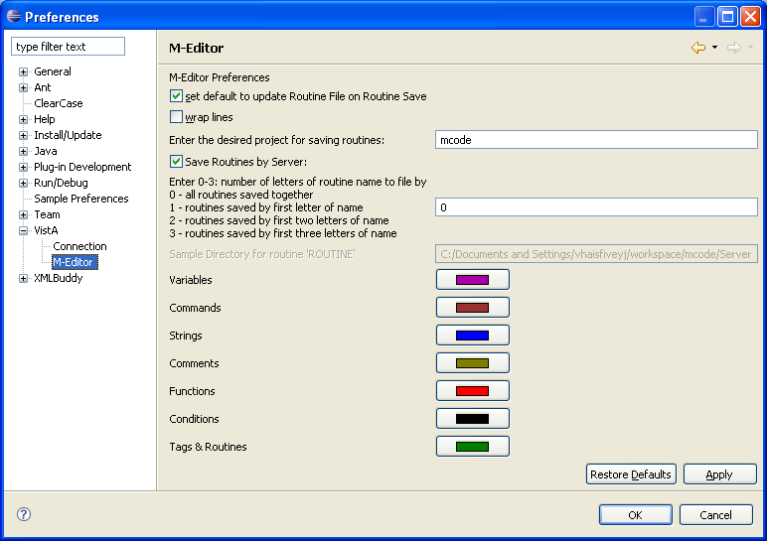
Working with the M-Editor in Eclipse
- During Initialization of the M-Editor in Eclipse with ClearCase (or setting up a new set of routines and project under version control), you may want to update all of the baseline routines to the current working set in the development account. This can be done by selecting the VistA – Multiple Routine Load option. Start by selecting all of the routines in the Package Explorer Window (at the left side of the IDE) that begin with the namespace you want to load (e.g., XUS) by selecting the first one, then moving to the last one and shift –clicking on it. Right Click the mouse and select Team – Check Out, and check out all of the routines in the namespace. Then click the menu VistA – Multiple Routine Load From Server. At the prompt specify the namespace you want to load from the VistA server (e.g., XUS). If the currently selected server is associated with the project (and you have already tried to load one routine, so the server has connected), it will indicate the project directory, otherwise enter a desired directory into which the routines should be loaded. Click OK, the routines will be loaded. Any routine which does not match the one currently on the workstation will be loaded, but an html indicating the differences will be generated and saved in a diff_htmls directory under the Eclipse directory (e.g., Eclipse\diff_htmls\) with the the routine name, server, project if applicable, and the date and time it was compared. If you want to update the ClearCase repository with the current files, then check the routines back in.
- To load a routine from the server you can select VistA – Load M routine from the menu bar, or click on the icon with the red M on a green background. [On the menu bar there is a VistA menu which contains items to connect and disconnect from a VistA server (although most of the time these are not necessary, since the user will be prompted to sign on when starting to perform a function that involves the server), Load a Routine from the server, generate global and routine directories, list globals, and perform multiple routine load and save operations.] 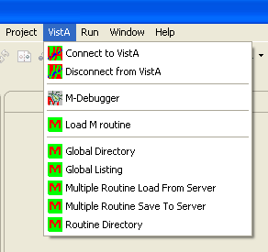 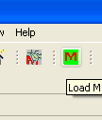
- The connection will be made with the primary server and the user prompted to sign on. 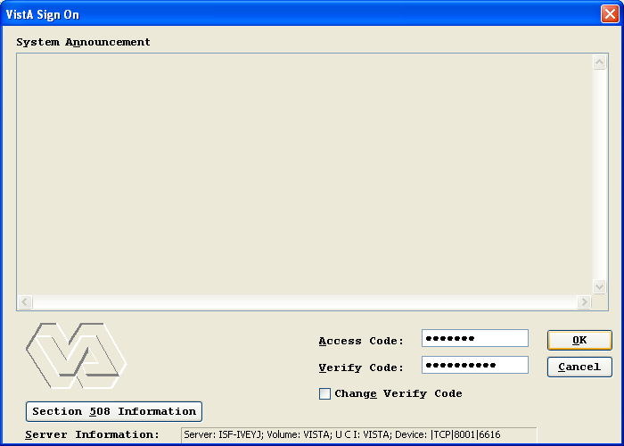
- Following sign-on, a prompt will appear for the name of the desired routine to load from the routine. 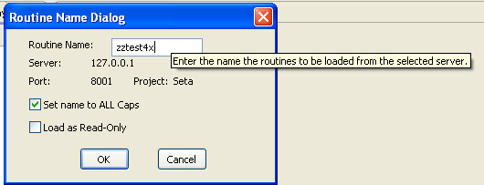
- If a the routine being loaded is under version control, and has not been checked out or hijacked, you may see an acess denied message (and other times you may just be prompted to check the routine out). 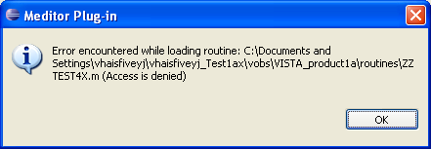
- To work with the ClearCase (or other version control functionality) from the editor perspective, select the routine name and right click the mouse to obtain the menu list. Toward the bottom select the Team item and a sub-menu of available items will appear. From this select Check Out or Hijack, as appropriate. 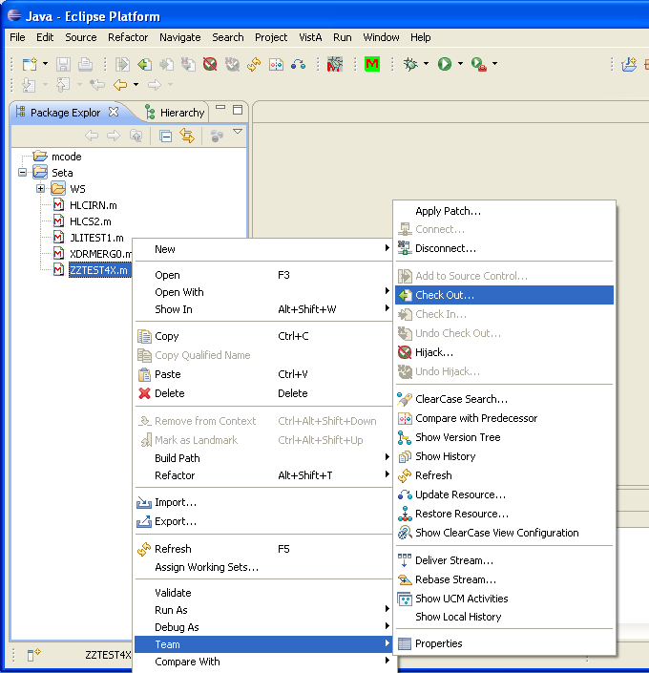
- To Check Out the item enter an Activity and click Apply. 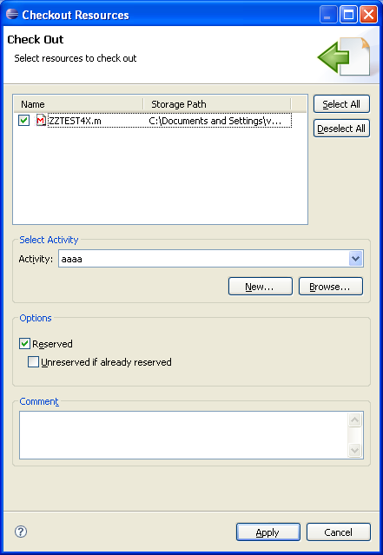 After which the icon for the routine will indicate that it is checked out. 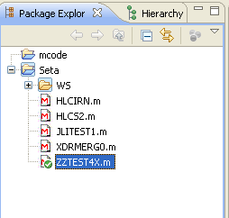
- If the routine that is being loaded has been loaded previously, and the one on the server does not match it, you will be notified. 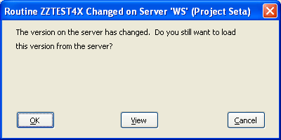
- If the View option is selected, a browser window will open showing the differences in the two versions. 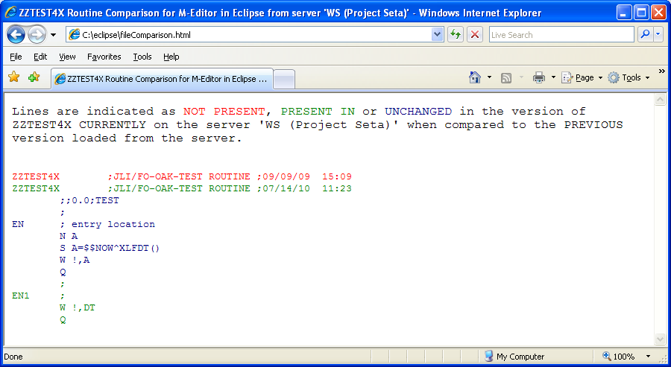 You may then decide to continue the load process by clicking the OK button or Cancel the process with the Cancel button.
- The loaded routine occupies the upper center portion of the IDE (and if the name tab at the top of the editing area is double clicked, the editing area will be expanded, double clicking the tab again will return to the original configuration. The outline are at the right lists each of the tags in the routine, and if a tag segment is longer, it will list them at increments of 10 lines. Clicking on one of these will take the user to the selected tag or line. The console area at the bottom will contain information after a routine has been saved. 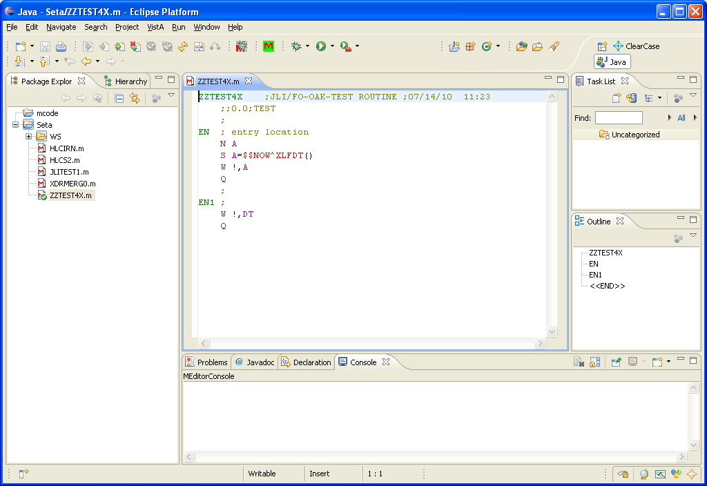
- As the routine is edited, lines that are modified or added are indicated in the channel at the left of the editing frame. [If you want to save a routine with no changes (e.g., to save it to a new server as well), you can add a space at the end of an existing line. On indicating that it should be saved, it indicate that it hasn't been modified and ask whether it should save with the original date or not.]
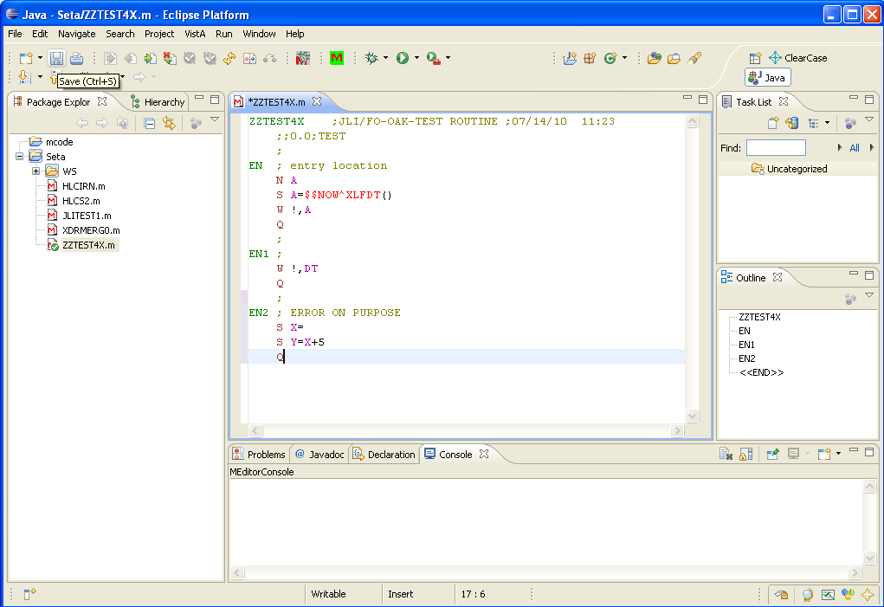
- To save a routine after it has been edited, you can select File – Save from the menu bar, enter Control-S or select the floppy disk icon (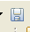for those who don't remember what a floppy disk looks like). The File – 'Save All' menu item is NOT supported, each edited routine needs to be saved separately.
- On saving the file, the M-Editor checks whether the version on the server has changed from when it was last loaded. If so, it displays a message and gives the user the options of viewign the difference(s) and/or continuing the save to the server, or cancelling (the edited version will already be saved on the workstation).
- When the routine is saved, XINDEX is run to check for errors and/or warnings and if any are identified, a dialog message appears. 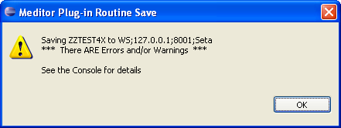
- The results of the routine save are shown in the MEditorConsole at the bottom of the IDE, indicating any errors and/or warnings, as well as any variables which are identified as neither NEWed or arguments [variables which are expected to be more than local can be identified using the comment line (for VAR1 and VAR2)]
<ls>;<space>ZEXCEPT:<space>VAR1,VAR2<spaces>reason and/or where it is created and killed
If a unit test routine is identified for the routine, it also will list the results for the unit tests as well. [A unit test routine can be specified at the time a new routine is created or by selecting the routine in the package explorer on the left side of the IDE, then selecting properties, and within the properties, select M-Editor and enter the unit test routine in the edit box.]
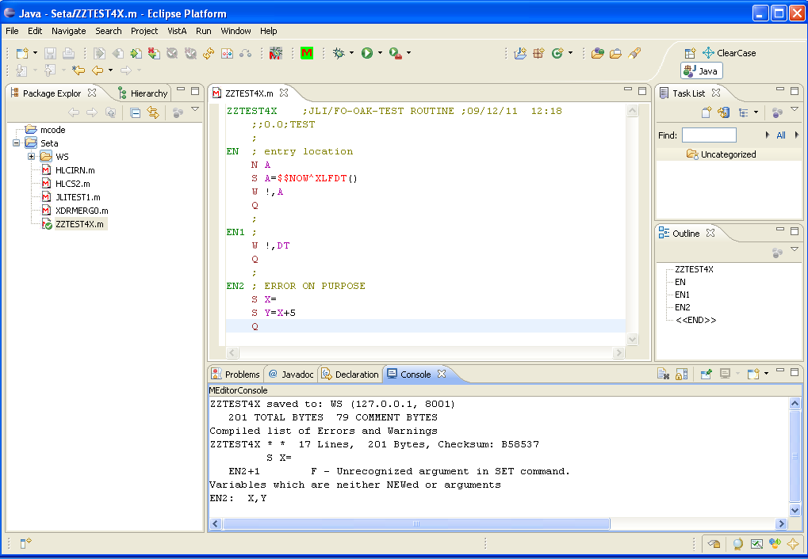
After Editing, fixing the error and NEWing the X,Y variables, saving results in a much nicer message. 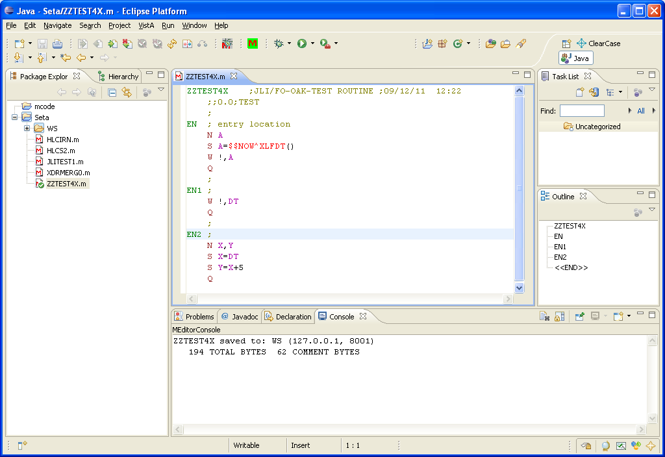
Checking in the modified routine can be accomplished by selecting routine, right-clicking and selecting the Team – 'Check In' menu item or by selecting the 'Check In' icon above. 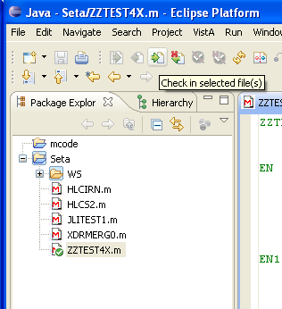 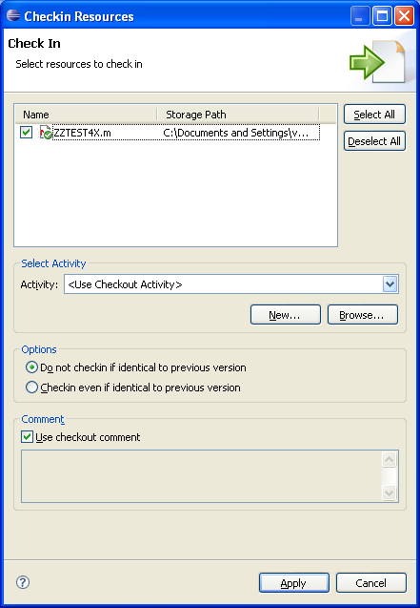
The Team context menu also provides functionality such as 'Show History' for the selected routine
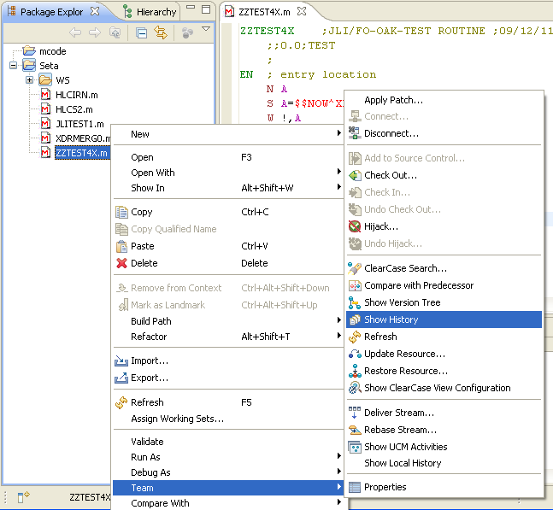
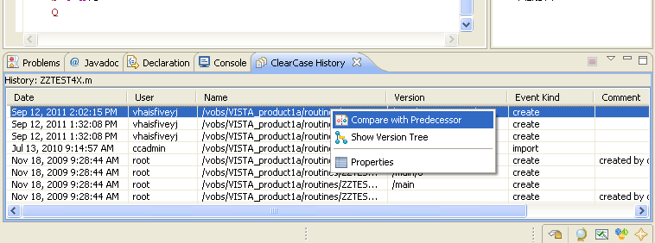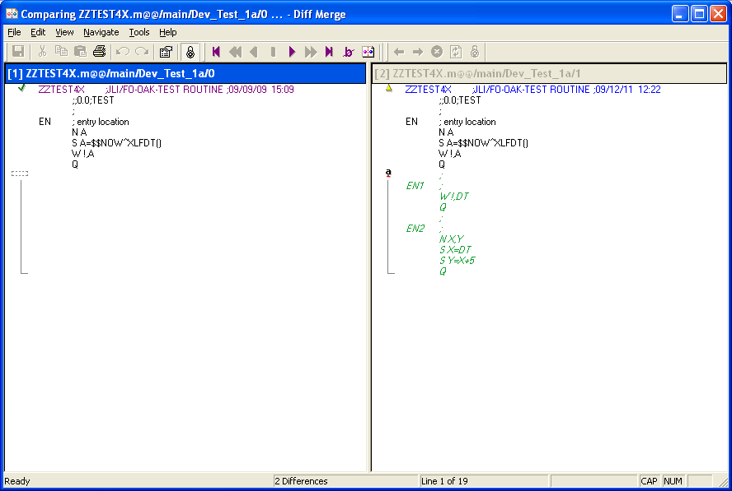
Even without ClearCase, similar functionality can be found in the context menu by right clicking a routine, then selecting 'Compare With' or 'Replace With' [These have a specified lifetime which can be set using the menu options Windows – Preferences and then selecting General – Workspace – Local History. Earlier versions of routines are also saved by the M-Editor in a backup directory under the area where the routines are saved.]

